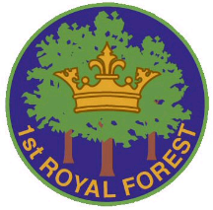 *1st Royal Forest Scout Group*

**Application for a grant to attend an international event**

**THIS FORM MUST BE COMPLETED BY THE APPLICANT.**

**What International Event are you attending**?

**Full Name**

**Current Section**

**History of scout membership:**

**Awards gained as a Beaver, Cub or Scout:**

**What do you hope to gain from attending the event?**

**What fund raising for this event have you carried out, either as a member of a team or individuall**y?

**Purpose of grant:**

**Applicants signature: Date:**

**Note only present members of the 1st Royal Forest Scout Group will be considered for a grant.**

For the 2019 Jamboree past members of the 1st Royal Forest Scout Group on this occasion may apply.

**Return the completed form to: Group Secretary, Brian Wingfield, 10 Hampshire Gardens, Coleford, GL16 8HU**

**DATA PROTECTION:** This form is used to collect information about you for the purpose of evaluating an application for a grant towards participation at an International Scouting event. As part of this form we collect personal data about you, this detail is required so that we can check that everyone meets the requirements for the grant. We do not share your personal data provided in this form with any third parties. We take your personal data privacy seriously. The data you provide to us is securely stored and we will keep the data we capture from this form for 6 months after the event for any queries that arise, then it will be securely destroyed.